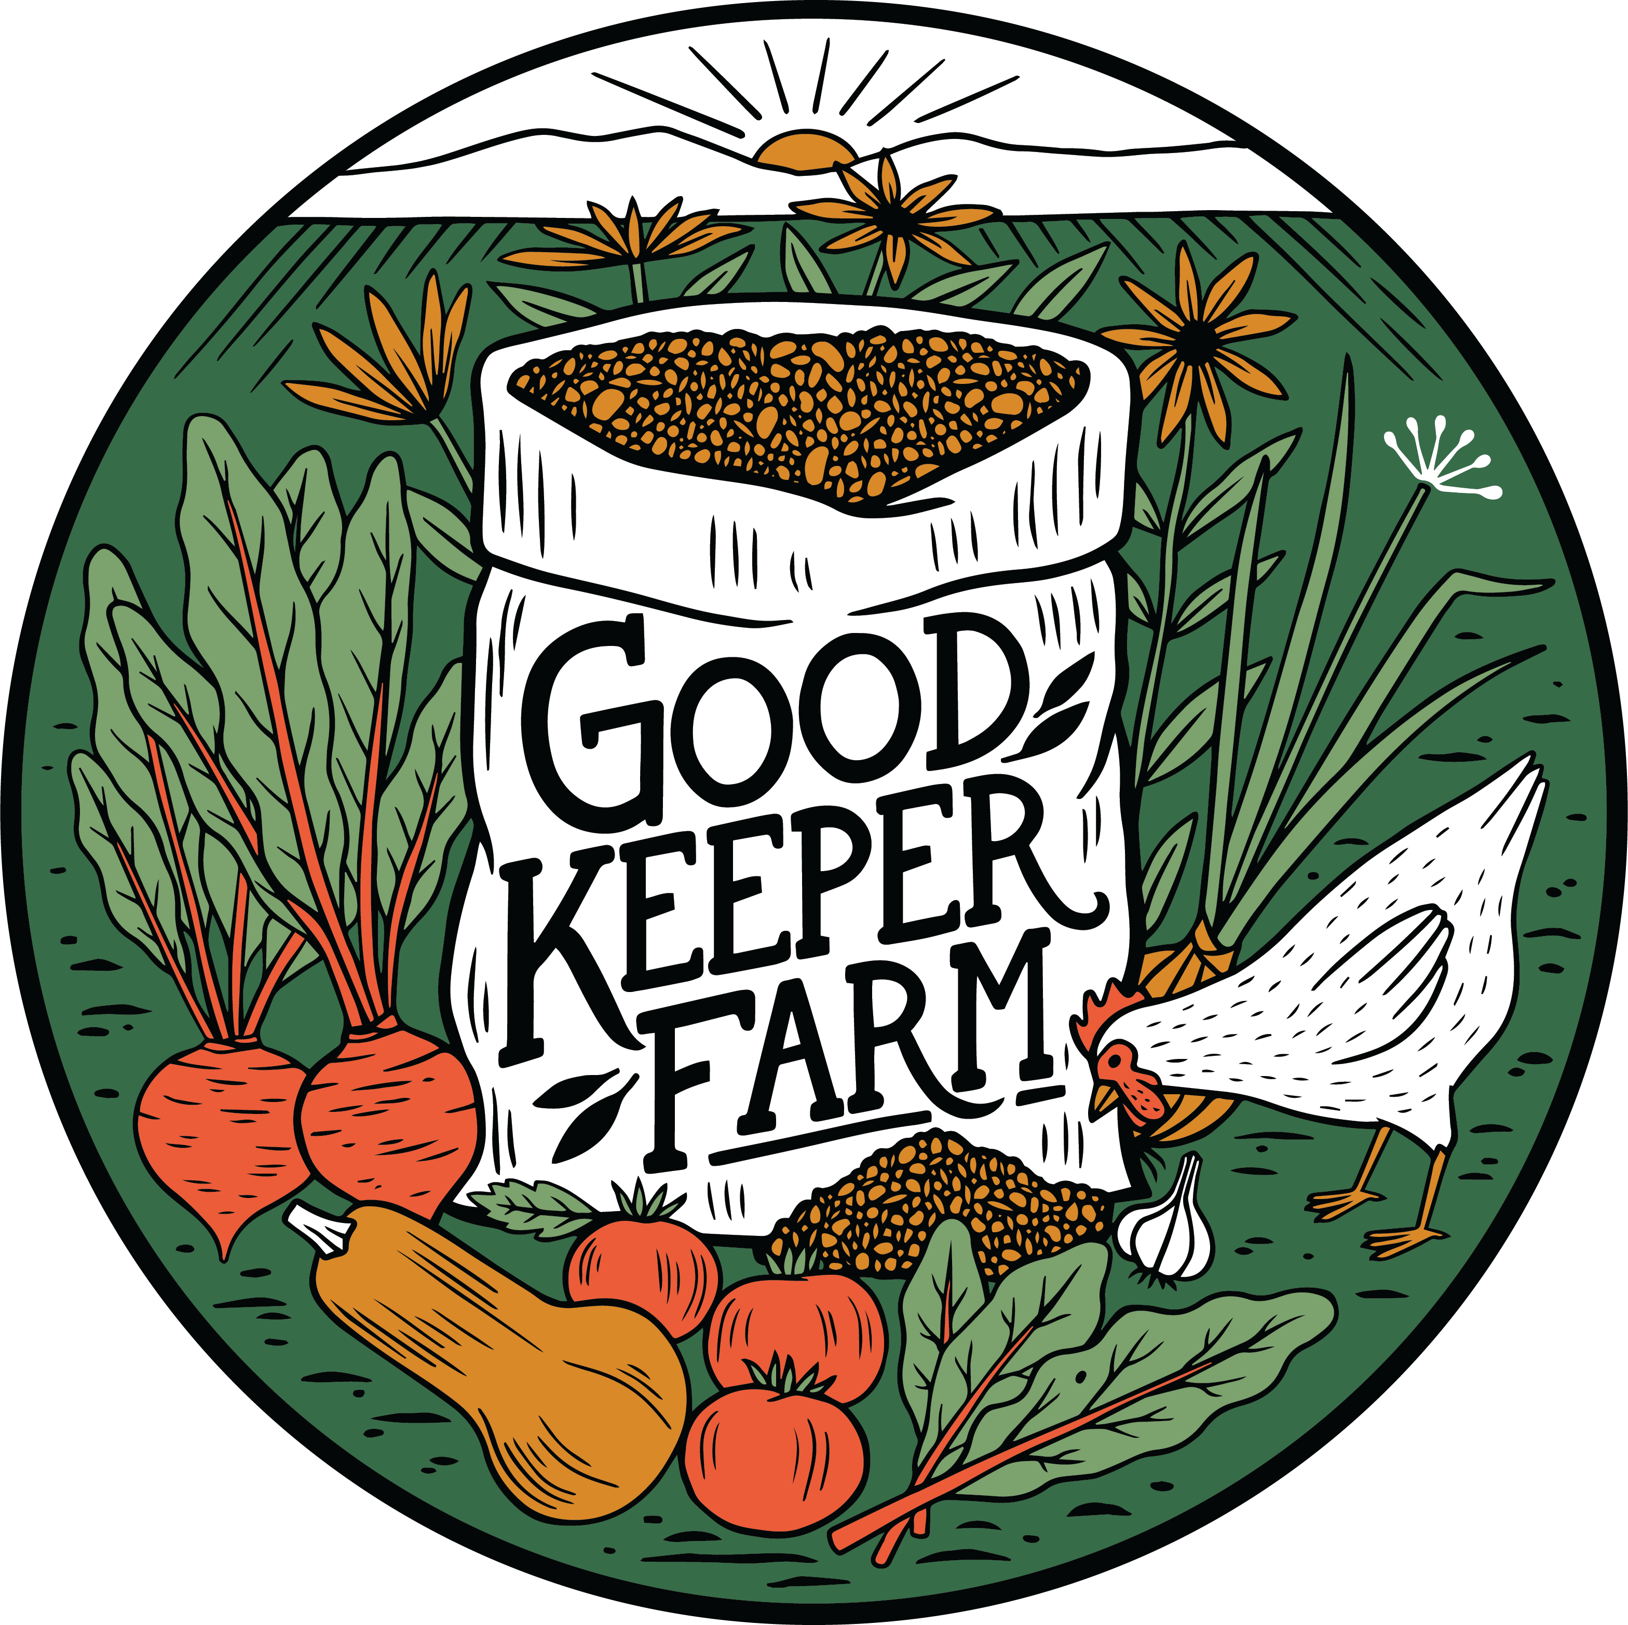
2023 FULL DIET CSA MEMBER FORM

Thank you for joining Good Keeper Farm’s CSA! Our mission is to efficiently and ecologically grow the highest quality vegetables, fruits, meats, and eggs, and to make it simple for our members to enjoy the delicious variety available strictly locally, in every season. We want to provide you with the foods you want, so please let us know if you eat a lot of certain vegetables. Make requests for foods you love, and we will do our best to include them!

This agreement represents our commitment to you. We will work hard to bring you the best and most delicious produce possible. We want you and your family to enjoy good eating by having a connection to the source of your food. In return, we need you to commit to us. Your commitment makes our livelihood possible.

Please take a few minutes to carefully read through this agreement as it will help us lay the groundwork for a successful year together.

- As a member, you come to the farm each week, either Tuesday 2pm to 8pm or Friday 2pm to 8pm, to pick up your foods. Please select one day or the other and stick to it. If complications arise, please get in touch to switch days. If pick up times are a restriction for you please email the farm and we will do our best to work with you.
- GKF’s free choice system means you may take, with rare exceptions, as much as is needed for one week by the paid members of your household.
- Every member of your household must be a member of the CSA.
- GKF Full Diet & Produce CSA is a 9 month commitment. This allows us to plan for abundance while avoiding waste.
- During the 9 month period you may skip up to 6 weekly pickups without being charged for that week. If you end up using all 6 weeks of vacation and need to skip another week you will be charged for that week. If you skip a week you have already paid for, you will be credited your next payment. Please consider finding family or friends that could take your place while you are away. If you do find family or friends to take your slot, they must pay according to their household size. Please make your friends aware of the policies and etiquette regarding how much food to take.
- Even for experienced growers weather conditions out of our control can destroy crops. By choosing to join our CSA you choose to share in this risk with the farmers.
- As a member you are entitled to bulk quantities of certain fruits and vegetables for preserving at home. We will announce to members when those quantities are available.
- The farm allows members to bring back egg cartons and berry containers every week and if in good condition we will reuse them in CSA distribution.
- Pickup times are subject to change. We are committed to making the pickup schedule work for everyone. If pick up times are changed due to weather or emergency we will alert you via email and/or text.
- A small number of items, especially the full variety of herbs, will be u-pick. These will be located near the pickup area. We will announce when those herbs or vegetables are available to pick.
- Meat is the most expensive product that we produce. With that knowledge, we please ask that you limit yourself to a reasonable level, that means taking on average 1-4lbs of mixed cuts per week per member. If you have a 4 members household you can take 4-16lbs of meat. (A single person can still take one of our large chickens, just please consider that between the meat and stock, it may be more than a week’s worth of meat.)
- Please be aware that we pay a $2 bottle deposit on every bottle. We ask that if you break a bottle at home or in the store that you pay us the deposit fee.
- When coming onto the farm we ask that you follow all farm signs for your safety and the safety of others. Please wash hands in the sink provided immediately before picking your own herbs or vegetables. Appropriate footwear is required; unseen hazards may exist. Please be aware that biting or stinging insects may be present on the farm. Exploration of the farm outside of the store and u-pick areas will require permission from Julie or Matt. Please be aware that there is a pond near the pickup area. Please watch for cars coming in and out during pick-up hours and monitor your children or anyone else under your care while on the farm property.
- Kids’ play equipment is available at the farm. It is your responsibility to evaluate the risk of using this equipment, and we assume no liability for injuries.
- In order for members to get more variety and choice out of our dairy options we have created a point system for yogurt, cheese and butter. Each member of your household gets 8 points per month for 9 months, which can be spent on plain whole milk yogurt (5 points), 5 different kinds of cheese (6 points), 1lb butters (8 points) and heavy cream products. Calculate points below.
- The cost is $78/per member/per week. Children are prorated: 13 and older $78, 12: $57, 11: $52, 10: $46, 9: $39, 8: $32, 7: $25, 6: $18, 5: $14, 4: $8, 3 and under FREE. You can pay by check, cash or auto-pay (preferred), either weekly, bimonthly, monthly or the whole year up front. We ask that all payment is paid before or on the day you pick up.

Please list every member of your household, age and price according to the prices above.
Name Age _______________________ Price ______
_____________________________________________________________________________________
_____________________________________________________________________________________
_________________________________________________________________________________________________________________________________________________________________________________________________________________________________________________________________________________________________________________________________________________________________________________________________________________________________________(Add prices per member)___TOTAL WEEKLY AMOUNT DUE:_______________________________
Dairy Points: (8 x # of people in household)= _____x 9(months)= ____ (dairy pnt for season)
Will you be paying by (circle one): CHECK CASH SET UP AUTO-PAY* (preferred)
*There is a separate form that will be sent for you to fill out
What day will you be picking up? (circle one): Tues. 2pm-8pm or Fri. 2pm-8pm
Phone number:______________________Can we text this number?_________
What is the best way to contact you for time sensitive communication: TEXT or EMAIL?
Email Address:__________________________________________________________
Street Address:___________________________________________________________________
By signing this form you are stating that you understand the terms and conditions of Good Keeper Farm’s CSA Membership. All information on this form will be kept confidential.

Signature: ___________________________________________Date:________________________
Thank you! We are so excited and honored to be able to grow food for you.

Julie Henninger and Matt Lowe
Farmers/Owners at Good Keeper Farm
250 Old State Road, Gardners, PA 17324

